Horizontal Tail Reference Data
Table 1.1: Horizontal tail data of home build aircraft
Type | 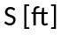² | 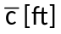 | 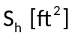 | 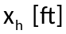 | 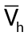
PIK-21 | 76.4 | 4.50 | 10.4 | 10.1 | 0.30
Durable RD-03C | 119 | 4.30 | 22.2 | 11.3 | 0.49
Piel CP-750 | 118 | 3.82 | 23.5 | 12.6 | 0.66
Piel CP-90 | 104 | 3.81 | 22.3 | 11.8 | 0.66
Pottier P-50R | 80.7 | 3.74 | 13.4 | 10.6 | 0.47
Pottier P-70S | 77.5 | 4.10 | 14.5 | 9.68 | 0.44
O-O Aerosport | 80.7 | 3.74 | 13.4 | 10.6 | 0.54
Aerocar Micro-Inp | 81.0 | 3.00 | 11.7 | 6.027 | 0.30
Coats SA-III | 112 | 4.50 | 16.5 | 10.9 | 0.36
Sequiois 300 | 130 | 4.37 | 25.5 | 13.2 | 0.59
Old Hume OH-4B | 125 | 5.25 | 25.4 | 11.1 | 0.49
Procter Petrel | 135 | 4.54 | 26.0 | 12.2 | 0.52
Bede BD-8 | 96.7 | 5.0 | 19.4 | 7.64 | 0.31

Table 1.2: Horizontal tail data of agricultural aircraft
Type | ²
PEL-104 | 167 | 4.60 | 34.0 | 17.3 | 0.77
PEL-106A | 306 | 6.23 | 81.4 | 18.6 | 0.79
PEL-M18 | 431 | 7.50 | 70.0 | 17.4 | 0.35
Embraer EMB-201A | 215 | 5.63 | 50.3 | 0.32 | 0.56
Cessna Ag Busky | 205 | 4.55 | 40.7 | 15.6 | 0.68
Schweizer Ag-Cat B | 392 | 4.83 | 45.0 | 12.9 | 0.31
Aero Boero 260Ag | 189 | 5.29 | 25.5 | 14.1 | 0.36
Let S-37A | 256 | 5.91 | 54.1 | 16.8 | 0.60
Hal HA-31 | 251 | 6.54 | 45.6 | 17.9 | 0.50
IAR-S22 | 280 | 6.90 | 48.4 | 17.4 | 0.44
Piper PA-36 | 226 | 6.22 | 43.3 | 15.0 | 0.46

Table 1.3: Horizontal tail data of single propeller aircraft
Type | ²
Cessna 207 Skywagon | 174 | 4.53 | 44.9 | 16.2 | 0.92
Cardinal RG | 174 | 4.79 | 35.0 | 14.3 | 0.60
Skylane RG | 174 | 4.52 | 38.8 | 14.3 | 0.71
Piper Cherokee Lance | 175 | 5.25 | 34.6 | 16.1 | 0.61
Piper Warrior | 170 | 4.44 | 26.5 | 13.5 | 0.48
Turbo Saratoga SP | 178 | 4.71 | 36.2 | 16.2 | 0.70
Bellance Skyrocket | 183 | 5.30 | 42.6 | 13.8 | 0.61
Grumman Tiger | 140 | 4.44 | 37.6 | 12.6 | 0.76
Rockwell Commander | 152 | 4.58 | 31.2 | 10.9 | 0.49
Trago Hills SAE-2 | 120 | 3.94 | 22.0 | 17.8 | 0.83
Scottish Aviation Bullfinch | 129 | 3.97 | 27.5 | 11.9 | 0.63

Table 1.4: Horizontal tail data of twin propeller aircraft
Type | ²
Cessna 310R | 179 | 4.77 | 34.3 | 14.9 | 0.95
Cessna 402B | 196 | 4.77 | 60.7 | 16.5 | 1.07
Cessna 414A | 226 | 4.73 | 60.7 | 16.4 | 0.93
Cessna T303 | 189 | 4.90 | 48.1 | 14.9 | 0.78
Piper PA-31P | 229 | 5.79 | 68.7 | 16.2 | 0.84
Piper PA-44-120T | 184 | 4.34 | 23.4 | 15.7 | 0.46
Piper Chieftain | 229 | 6.00 | 61.4 | 16.1 | 0.72
Piper Cheyenne I | 229 | 5.69 | 70.5 | 15.7 | 0.85
Piper Cheyenne III | 293 | 7.33 | 61.8 | 23.7 | 0.68
Beech Duchess | 181 | 5.08 | 39.4 | 15.6 | 0.67
Beech Duke B60 | 213 | 6.60 | 62.0 | 14.5 | 0.64
Lear Fan 2100 | 163 | 4.36 | 55.0 | 12.1 | 1.01
Rockwell Commander 700 | 200 | 5.28 | 55.4 | 19.7 | 1.03
Piaggio P166-DL3 | 286 | 6.06 | 51.6 | 17.2 | 0.51
Embrear EMB-121 | 296 | 6.62 | 62.7 | 20.3 | 0.65

Table 1.5: Horizontal tail data of regional turboprop aircraft
Type | ²
CASA C-212-200 | 431 | 6.68 | 135 | 24.9 | 1.17
Shorts 330 | 453 | 6.06 | 83.6 | 27.3 | 0.83
Shorts 360 | 453 | 6.06 | 106 | 33.0 | 1.28
Beech 1900 | 303 | 5.35 | 71.3 | 30.3 | 1.33
Beech B200 | 303 | 5.35 | 68.0 | 24.6 | 0.91
Cessna Conquest I | 225 | 4.73 | 62.0 | 16.4 | 0.95
Cessna Conquest II | 254 | 4.98 | 63.4 | 18.0 | 0.90
GA Ic | 610 | 8.28 | 134 | 36.5 | 0.97
GAF N22B | 324 | 5.94 | 78.0 | 20.6 | 0.83
Fokker F-27-200 | 754 | 8.43 | 172 | 96.0 | 0.98
DeHavilland Cananda DHC-6 | 420 | 6.5 | 100 | 24.8 | 0.91
DeHavilland Cananda DHC-7 | 860 | 9.45 | 217 | 41.6 | 1.11
DeHavilland Cananda DHC-8 | 585 | 6.51 | 154 | 36.3 | 1.47
Embraer EMB-120 | 409 | 6.57 | 108 | 31.7 | 1.27
BAe 31 | 270 | 5.27 | 84.0 | 20.7 | 1.22
Metro III | 309 | 6.03 | 76.0 | 26.1 | 1.07

Table 1.6: Horizontal tail data of business jets
Type | ²
Dassault Falcon 10 | 259 | 6.71 | 72.7 | 16.5 | 0.69
Dassault Falcon 20 | 440 | 9.33 | 122 | 21.9 | 0.65
Dassault Falcon 50 | 495 | 9.31 | 144 | 21.7 | 0.68
Cessna Citation 550 | 260 | 6.44 | 70.6 | 17.1 | 0.73
Cessna Citation II | 323 | 6.77 | 73.1 | 19.2 | 0.64
Cessna Citation III | 312 | 6.07 | 69.6 | 26.9 | 0.99
Canadair CL-601 Challenger | 450 | 11.3 | 105 | 32.2 | 0.67
Aerospatiale SN-601 | 237 | 5.60 | 58.9 | 16.7 | 0.74
Israël Aircraft Ind. Astra | 317 | 5.62 | 77.1 | 22.8 | 0.99
Israël Aircraft Ind. Westwind | 308 | 7.58 | 70.1 | 19.8 | 0.59
British Aerospace HS125-700 | 353 | 7.52 | 100 | 19.1 | 0.72
G.A.-III | 35 | 13.8 | 184 | 356 | 0.51
MU Diam.I | 241 | 6.23 | 57.2 | 23.4 | 0.85

Table 1.7: Horizontal tail data of passenger transport jet aircraft
Type | ²
Boeing 727-200 | 1700 | 18.0 | 376 | 67.0 | 0.82
Boeing 737-200 | 980 | 11.2 | 321 | 43.8 | 1.28
Boeing 737-300 | 1117 | 10.9 | 390 | 49.7 | 1.35
Boeing 747-200B | 5500 | 38.0 | 1470 | 104.5 | 0.74
Boeing 747SP | 5500 | 38.0 | 1534 | 72.9 | 0.54
Boeing 757-200 | 1951 | 14.9 | 585 | 56.9 | 1.15
Boeing 767-200 | 3050 | 19.8 | 836 | 67.6 | 0.94
McDonnell Douglas DC-9-30 | 1270 | 15.7 | 314 | 61.4 | 0.96
McDonnell Douglas DC-9-50 | 1001 | 11.8 | 276 | 56.8 | 1.32
McDonnell Douglas DC-10-30 | 3958 | 24.7 | 1338 | 65.9 | 0.90
Airbus A300B4 | 2799 | 19.2 | 748 | 80.4 | 1.12
Airbus A310 | 2357 | 19.9 | 689 | 72.0 | 1.09
Lockheed L1011-500 | 3541 | 24.5 | 1282 | 55.9 | 0.83
Fokker F-28-4000 | 850 | 10.9 | 210 | 47.2 | 1.07
BAC 1-11 495 | 1031 | 11.8 | 258 | 40.7 | 0.86
BAe 146-200 | 832 | 20.2 | 276 | 45.3 | 1.48
Tupolev Tu-154 | 2169 | 16.7 | 436 | 58.9 | 0.71

Table 1.8: Horizontal tail data of military trainers
Type | ²
Propeller driven
Embraer EMB-312 | 209 | 5.77 | 49.2 | 16.9 | 0.69
Pilatus PC-7 | 179 | 5.23 | 36.9 | 16.2 | 0.64
NDN 1T | 126 | 5.4 | 25.8 | 14.0 | 0.53
T-34C | 180 | 4.01 | 37.2 | 14.8 | 0.76
Epsilon | 96.9 | 3.97 | 21.5 | 13.8 | 0.77
SF-260M | 109 | 4.35 | 26.0 | 12.7 | 0.70
Yak-52 | 162 | 5.20 | 30.8 | 13.3 | 0.49
Naiva T25 | 185 | 5.19 | 33.0 | 15.0 | 0.52
Jet driven
Aero L39C | 202 | 7.04 | 54.6 | 15.2 | 0.58
Microturbo Microjet 200B | 65.9 | 2.79 | 22.9 | 8.98 | 1.12
Alphajet | 188 | 7.37 | 42.4 | 14.1 | 0.43
Aermacchi MB-339A | 208 | 6.34 | 46.9 | 14.6 | 0.52
SM S-211 | 136 | 5.40 | 36.4 | 15.2 | 0.75
PEL TS-11 | 188 | 5.80 | 38.1 | 16.3 | 0.57
CASA C101 | 215 | 6.32 | 47.8 | 15.2 | 0.54
BAe Hawk Mk1 | 180 | 6.30 | 46.6 | 14.8 | 0.61

Table 1.9: Horizontal tail data of fighters
Type | ²
Dassault Mirage IIIE | 377 | 17.7 | 0 | 0 | 0
Dassault Mirage F1C | 269 | 10.4 | 96.9 | 14.9 | 0.51
Dassault Mirage 2000 | 441 | 18.2 | 0 | 0 | 0
Super Et. | 306 | 10.5 | 59.7 | 15.5 | 0.29
PR A-10A | 506 | 8.94 | 89.4 | 20.6 | 0.41
Grumman A-6A | 529 | 10.9 | 109.8 | 24.2 | 0.46
Grumman F-14A | 565 | 10.2 | 140 | 16.4 | 0.40
Northrop F-5E | 186 | 8.05 | 59.0 | 13.0 | 0.51
McDonnell Douglas F-4E | 530 | 15.5 | 96.9 | 22.2 | 0.26
McDonnell Douglas F-15 | 608 | 17.8 | 104 | 20.7 | 0.20
General Dynamics FB-111A | 476 | 8.22 | 468 | 17.6 | 0.75
General Dynamics F-16 | 300 | 11.4 | 66.6 | 15.4 | 0.30
Cessna A-37B | 184 | 5.61 | 46.7 | 15.1 | 0.68
Aermacchi MB339K | 208 | 6.30 | 26.4 | 14.5 | 0.40
Mikojan-Goerevitsj MiG-25 | 612 | 17.3 | 236 | 16.0 | 0.36
Sukhoi Su-7BMK | 329 | 12.5 | 92.7 | 17.9 | 0.40

Table 1.10: Horizontal tail data of military patrol, bomb and transport aircraft
Type | ²
Turboprop driven
Lockheed C-130E | 1745 | 13.7 | 536 | 42.1 | 0.94
Lockheed P-3C | 1300 | 14.1 | 322 | 48.5 | 0.85
Antonov An-12BP | 1310 | 11.3 | 319 | 52.5 | 1.13
Antonov An-22 | 3713 | 18.8 | 846 | 87.4 | 1.06
Antonov An-26 | 807 | 8.79 | 213 | 13.3 | 1.31
Grumman E-2C | 700 | 9.73 | 174 | 26.9 | 0.69
D/B Atlantique 2 | 1295 | 11.5 | 355 | 43.4 | 1.04
Aeritalia G222 | 883 | 8.65 | 255 | 37.0 | 1.24
Jet driven
Lockheed S-3A Viking | 598 | 9.85 | 176 | 20.0 | 0.60
Lockheed C-141B | 3406 | 21.4 | 545 | 82.5 | 0.62
Lockheed C-5A | 6200 | 32.9 | 966 | 130.4 | 0.62
BAe Nimrod 2 | 2121 | 20.5 | 435 | 50.5 | 0.51
Boeing YC-14 | 1762 | 16.8 | 690 | 61.5 | 1.43
McDonnell Douglas KC-10A | 3958 | 24.7 | 1338 | 65.1 | 0.89
Tupolev Tu-16 | 1772 | 15.9 | 360 | 50.6 | 0.65
Ilyushin Il-76T | 3229 | 20.7 | 639 | 71.2 | 0.68

Tail plane parameters

Besides the horizontal tail area, there are other important parameters which are also important for the following design steps (e.g. Class 2 weight estimation). The values for the aspect ratio, the taper ratio, the sweep angle of leading edge and quarter chord line can be based on statistics. In Figure 1.1 and Figure 1.2 statistical data of different aircraft categories is given.

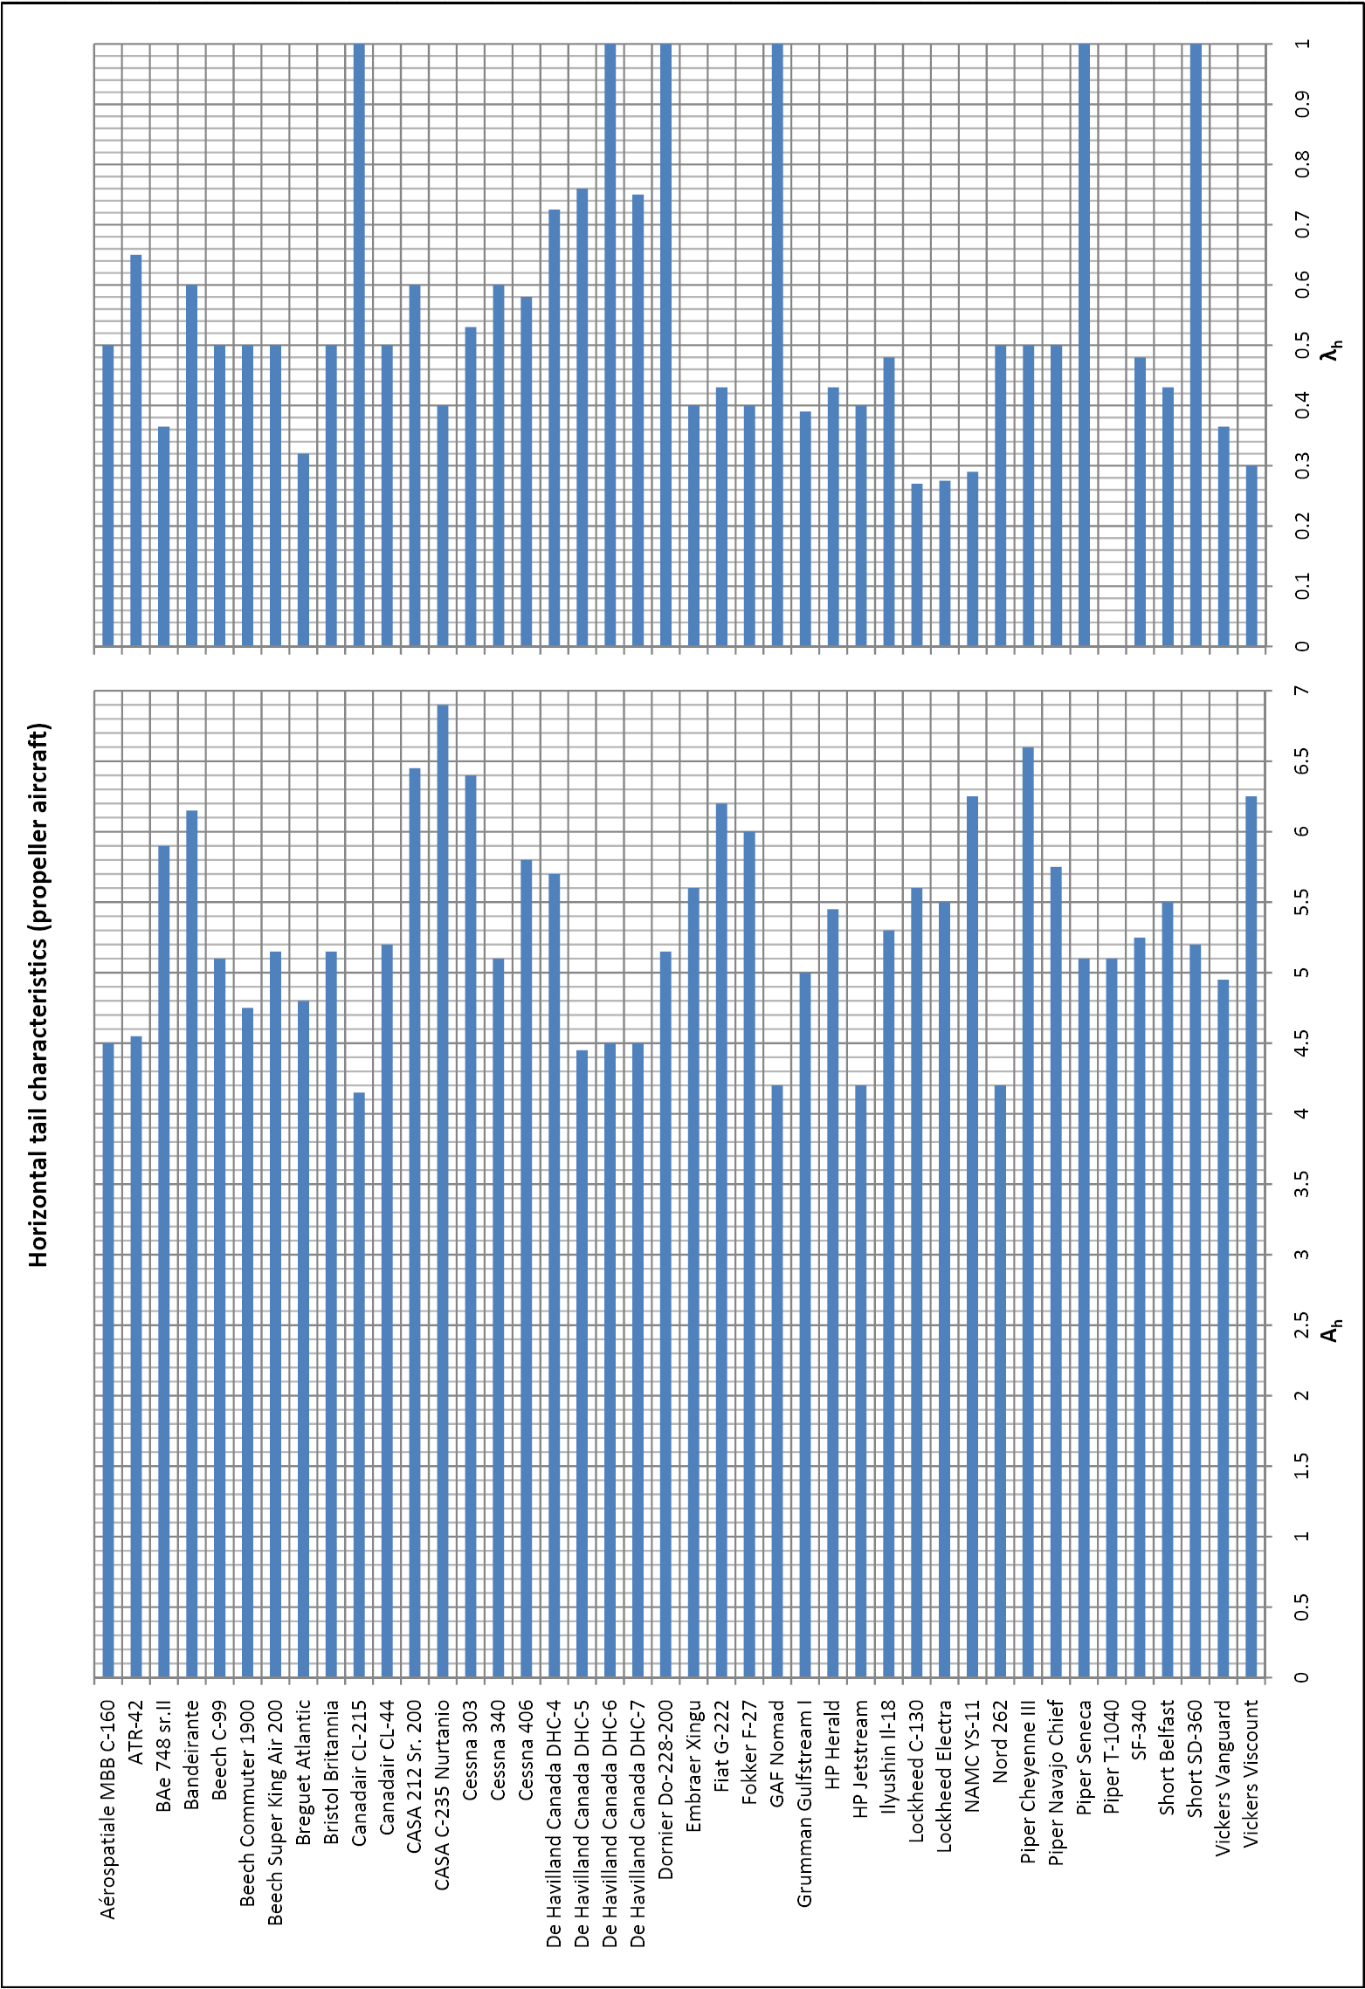
Figure 1.1: Horizontal tail data propeller aircraft

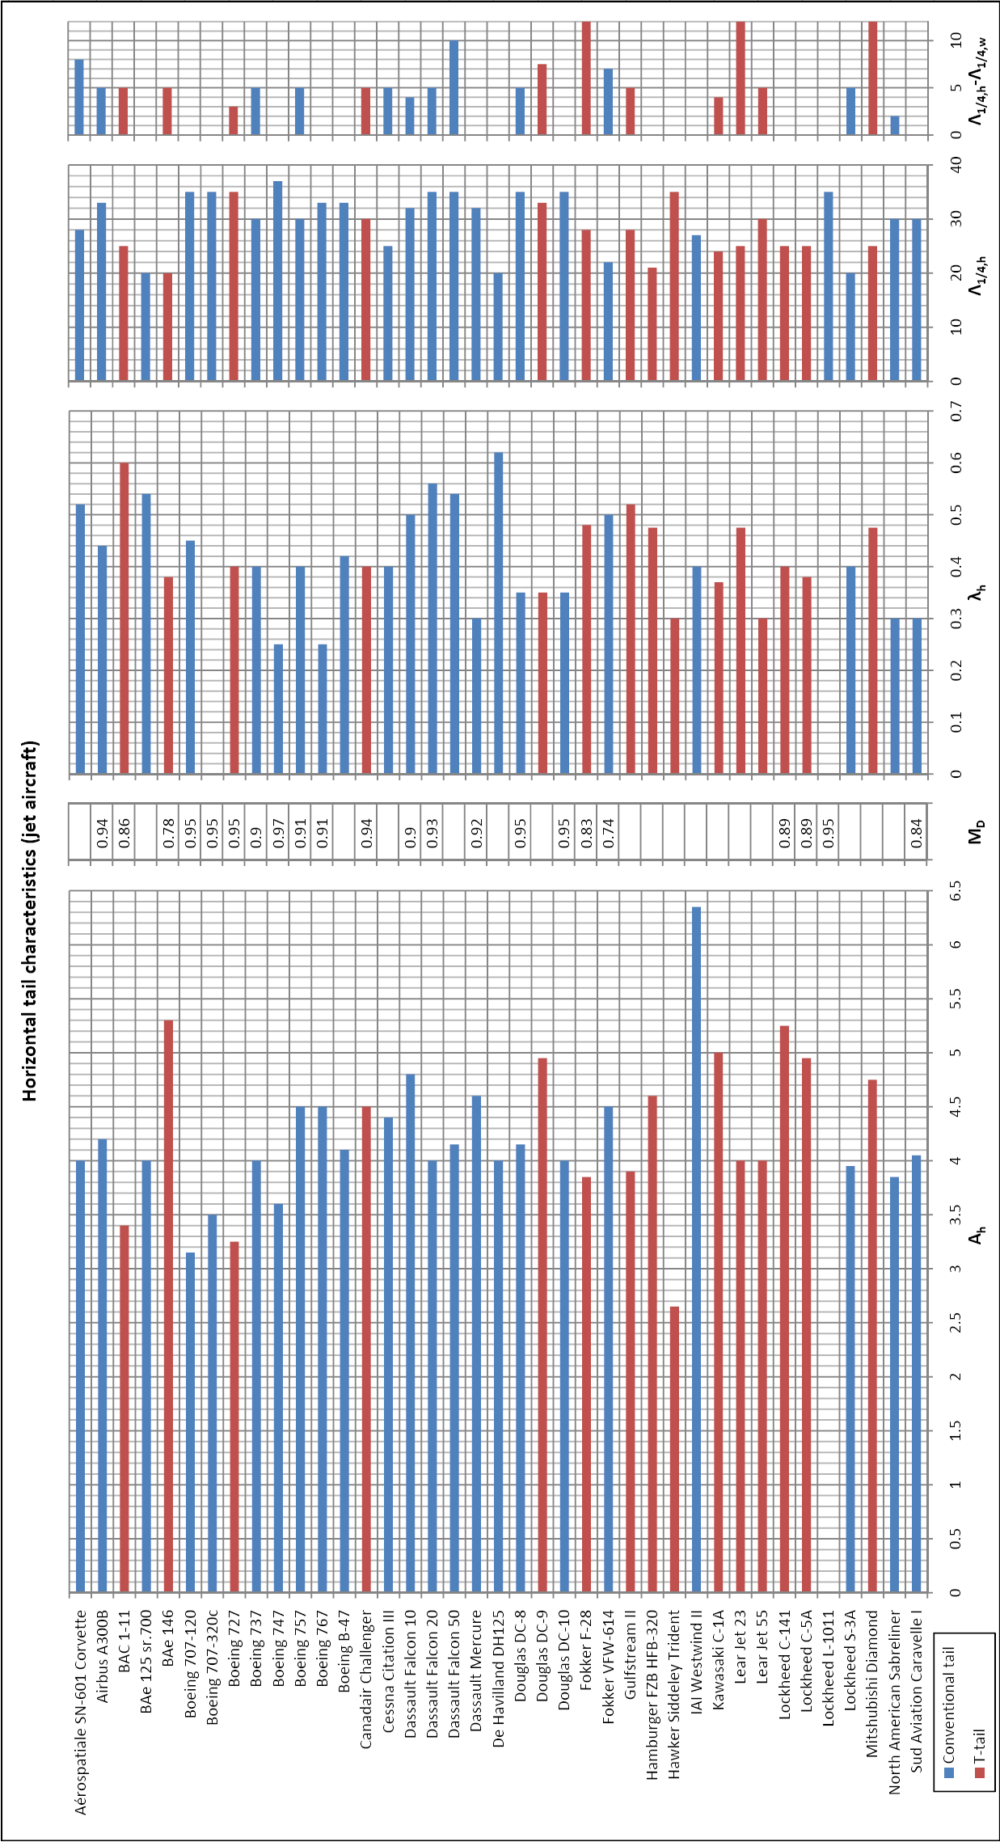
Figure 1.2: Horizontal tail data jet aircraft

